**F. Y. B. Tech Academic Year 2021-22**

**Subject:** Basics of Electrical and Electronics Engineering **Trimester: I**

**Name:** Shreerang Mhatre **Division: 11**

**Roll No:** 111056 **Batch: K3**

**Experiment No: 5**

**Name of the Experiment**: Design of inverting and non-inverting amplifiers using OPAMP.

**Performed on: 14/01/2022**

**Submitted on: 16/01/2022**

**Aim: Design of inverting and non-inverting amplifiers using OPAMP.**

**Prerequisite:**

* Understanding of ideal and practical parameters of OPAMP

**Objectives:**

* To get familiar with OPAMP as an amplifier
* To identify the pins of an OPAMP such as LM 741
* To measure gain of OPAMP and compare it with theoretical value
* To understand the different configurations of OPAMP

**Components and equipment required:**

Function generator, CRO, regulated power supply, resistors, capacitors, OPAMP LM741 circuit board, connecting wires, etc.

**Theory:**

An ‘ideal’ or perfect operational amplifier is a device with certain special characteristics such as infinite open-loop gain *Ao*, infinite input resistance *Rin*, zero output resistance *Rout*, infinite bandwidth and zero offset (the output is exactly zero when the input is zero). The amplified output signal of an operational amplifier is the difference between the two signals applied to the two inputs. The most commonly available and used of all operational amplifiers in basic electronic circuits is OPAMP 741. The basic symbol of OPAMP is shown in Fig. 7.1 and detailed pin diagram of general purpose OPAMP 741 is shown in Fig. 7.2.

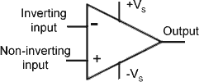

**Fig.7.1 Symbol of OPAMP**

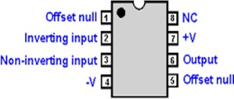

**Fig.7.2 Pin diagram of OPAMP 741**

Open Loop Gain, (*AVL*) of an ideal operational amplifier can be very high, as much as 1,000,000 (120 dB) or more. However, this very high gain is of no real use as it makes the amplifier both, unstable and hard to control as the smallest of input signals, just a few micro- volts, (μV) would be enough to cause the output voltage to saturate and swing towards one or the other of the voltage supply losing complete control. As the open loop gain of an operational amplifier is extremely high, we can therefore afford to lose some of this high gain by connecting a suitable resistor across the amplifier from the output terminal back to the inverting input terminal to reduce and control the overall gain of the amplifier. This then produces an effect known commonly as negative feedback, and thus produces a very stable operational amplifier.

**Table 7.1 Ideal and practical characteristics of OPAMP 741**

|  |  |  |  |
| --- | --- | --- | --- |
| **Sr.**  **No.** | **Parameter** | **Ideal** | **General purpose**  **741 Op-Amp** |
| 1 | Open-loop voltage gain,  Go(V/V) | ∞ | 2,00,000 |
| 2 | Input impedance, Zin(Ω) | ∞ | 2 MΩ |
| 3 | Output impedance, Zo(Ω) | 0 | 75 Ω |
| 4 | Input Offset current, Iio (nA) | 0 | 20 nA |
| 5 | Input Bias current, Iib (nA) | 0 | 80 nA |
| 6 | Input Offset voltage, Vio  (mV) | 0 | 2 mV |
| 7 | Slew rate, SR (V/μs) | ∞ | 0.7 V/μs |
| 8 | CMRR | ∞ | 90 dB |
| 9 | SVRR / PSRR | ∞ | 96 dB |

|  |  |  |  |
| --- | --- | --- | --- |
|  |  |  |  |
| 10 | Bandwidth BW | ∞ | 1 MHz |

Negative Feedback is the process of feeding back a fraction of the output signal back to the input, but to make the feedback negative, we must feed it back to the negative or inverting input terminal of the OPAMP using an external feedback resistor called *Rf*. This effect produces a closed loop circuit to the amplifier resulting in the gain of the amplifier now being called its closed-loop gain. The closed-loop inverting amplifier uses negative feedback to accurately control the overall gain of the amplifier, improves input output impedance, increases the bandwidth but at a cost of reduction of the amplifiers gain. The ideal and practical characteristics of an OPAMP IC 741 are given in Table 7.1. Using negative feedback OPAMP can be used as an inverting and non-inverting amplifier.

**Inverting Amplifier:**

An inverting-amplifier circuit is built by grounding the positive input of the operational amplifier and connecting resistors *R1* and *R2*, called the feedback networks, between the inverting input and the signal source and amplifier output node, respectively as shown in Fig. 7.3. The analysis of the circuit is performed by relating current *I1* with *If* and then calculating the output voltage *Vo*. Gain of the amplifier is given by:

(7.1)

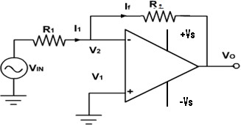

**Fig. 7.3 Inverting amplifier configuration of an OPAMP**

**Non-Inverting Amplifier:**

The operational amplifier can also be used to construct a non-inverting amplifier with the circuit indicated in Fig. 7.4. The input signal is applied to the positive or non- inverting input terminal of the operational amplifier, and a portion of the output signal is fed back to the negative input terminal. Analysis of the circuit is performed by relating the voltage at V2 to both the input voltage Vin and the output voltage Vo. Gain of the amplifier is given by:

(7.2)

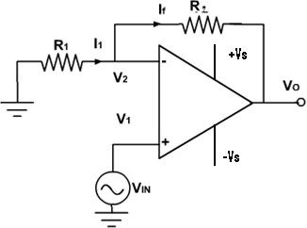

**Fig. 7.4 Non-inverting amplifier configuration of an OPAMP**

**Procedure:**

1. Connect the circuit for inverting amplifier as shown in the circuit diagram.
2. Select resistors R1 and R2 provided on the circuit board.
3. Set +Vs to +15 V and -Vs to -15V by using the dual power supply and switch on the supply.
4. Apply sine wave input in the range of 500 mV to 1 V using signal generator.
5. Measure the peak to peak input and output voltages on CRO.
6. Calculate theoretical gain value using Eq. 7.1 for inverting amplifier and Eq. 7.2 for non-inverting amplifier and compare it with the experimental value obtained by dividing output voltage by the input voltage.
7. Draw input and output waveforms on the graph sheet.
8. Observe outputs of the amplifier circuit using different values of R1 and R2.
9. Repeat steps 2 to 8 for non-inverting amplifier configuration.

**Observation Table:**

**1****. Inverting Amplifier( AC input)**

|  |  |  |  |  |  |  |
| --- | --- | --- | --- | --- | --- | --- |
| **Sr.**  **No.** | **Input Voltage**  ***Vin*** | ***R1*** | ***R2*** | **Output Voltage *Vo*** | **Gain (Practical)**  **Vo / Vin** | **Gain (Theoretical)**  **-R2 / R1** |
| 1 | 200mv | 10 KΩ | 100 KΩ | 20 V | -10 | -10 |
| 2 | 300mv | 20 KΩ | 80 KΩ | 12 V | -4 | -4 |
| 3 | 400mv | 10 KΩ | 30 KΩ | 12V | -3 | -3 |
| 4 | 1v | 15 KΩ | 75 KΩ | 5V | -5 | -5 |
| 5 | 2v | 10 KΩ | 60 KΩ | 12V | -6 | -6 |

1. **Inverting Amplifier(DC input)**

|  |  |  |  |  |  |  |
| --- | --- | --- | --- | --- | --- | --- |
| **Sr.**  **No.** | **Input Voltage *Vi***  **(DC)** | ***R1*** | ***R2*** | **Output Voltage *Vo*** | **Gain (Practical)**  **Vo / Vin** | **Gain (Theoretical)**  **-R2 / R1** |
| 1 | 200mv | 10 KΩ | 100 KΩ | 20 V | -10 | -10 |
| 2 | 300mv | 20 KΩ | 80 KΩ | 12 V | -4 | -4 |
| 3 | 500mv | 10 KΩ | 30 KΩ | 12.8 V | -3 | -3 |
| 4 | 1v | 15 KΩ | 75 KΩ | 5 V | -5 | -5 |
| 5 | 1.5v | 10 KΩ | 60 KΩ | 6 V | -6 | -6 |

1. **Non-Inverting Amplifier (AC Input)**

|  |  |  |  |  |  |  |
| --- | --- | --- | --- | --- | --- | --- |
| **Sr.**  **No.** | **Input Voltage**  ***Vin (AC)*** | ***R1*** | ***R2*** | **Output Voltage *Vo*** | **Gain (Practical)**  **Vo / Vin** | **Gain (Theoretical)**  **1+ (R2 / R1)** |
| 1 | 200mv | 10 KΩ | 100 KΩ | 22 V | 11 | 11 |
| 2 | 300mv | 20 KΩ | 80 KΩ | 1.5 V | 5 | 5 |
| 3 | 400mv | 10 KΩ | 30 KΩ | 2 V | 4 | 4 |
| 4 | 1v | 15 KΩ | 75 KΩ | 6 V | 6 | 6 |
| 5 | 2v | 10 KΩ | 60 KΩ | 10.5 V | 7 | 7 |

1. **Non-Inverting Amplifier (DC Input)**

|  |  |  |  |  |  |  |
| --- | --- | --- | --- | --- | --- | --- |
| **Sr.**  **No.** | **Input Voltage**  ***Vin*** | ***R1*** | ***R2*** | **Output Voltage *Vo*** | **Gain (Practical)**  **Vo / Vin** | **Gain (Theoretical)**  **1+ (R2 / R1)** |
| 1 | 200mv | 10 KΩ | 100 KΩ | 22 V | 11 | 11 |
| 2 | 300mV | 20 KΩ | 80 KΩ | 1.5V | 5 | 5 |
| 3 | 500mV | 10 KΩ | 30 KΩ | 2V | 4 | 4 |
| 4 | 1V | 15 KΩ | 75 KΩ | 6V | 6 | 6 |
| 5 | 1.5v | 10 KΩ | 60 KΩ | 10.5V | 7 | 7 |

**Note: Students are instructed to do all the necessary calculations on separate sheets.**

**Conclusion:**

Thus, we have learnt and understood the working of OP AMP as an amplifier and also studied the working of OP AMP in different configurations, including the study of its pins. We have also calculated the gain of OP AMP and compared it with the theoretical gain values as mentioned above.

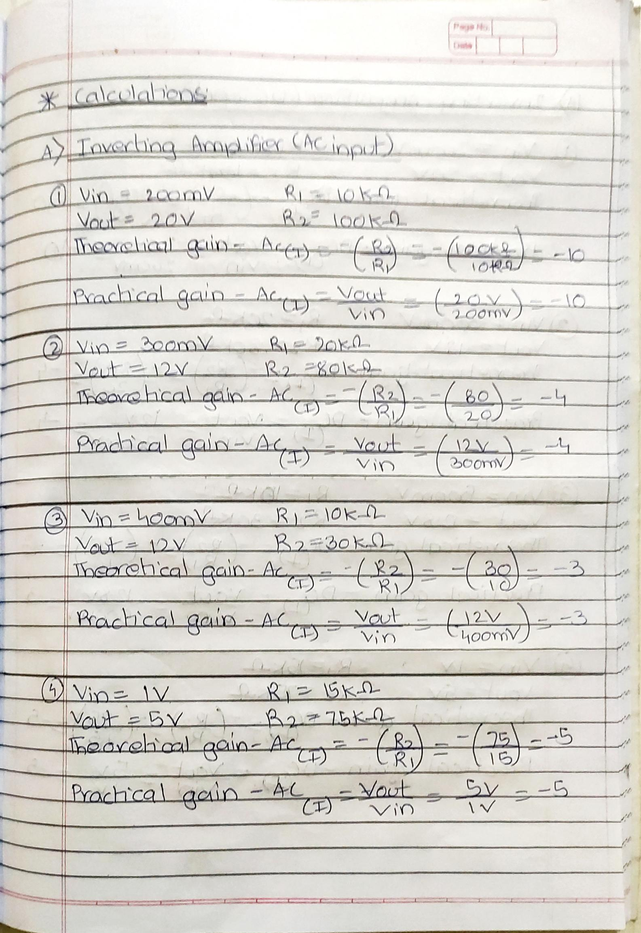

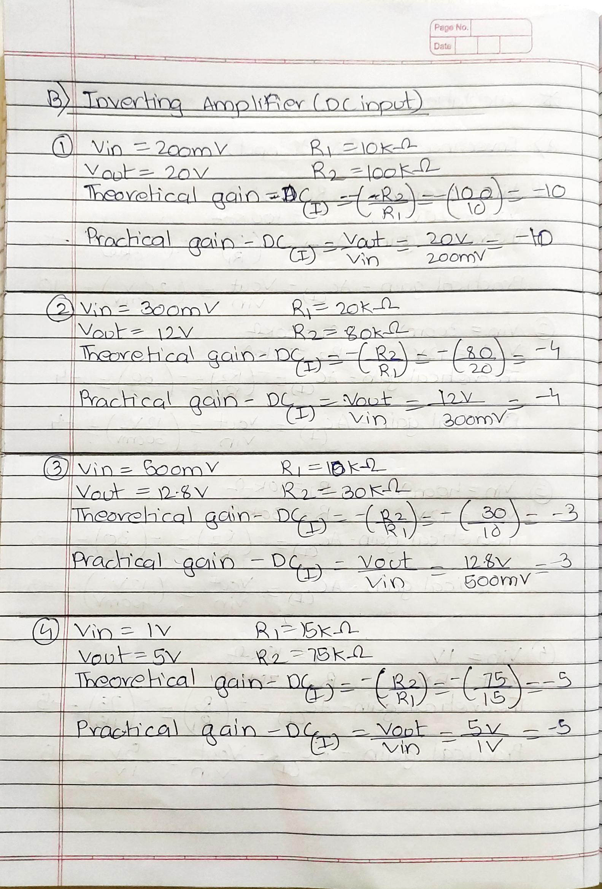

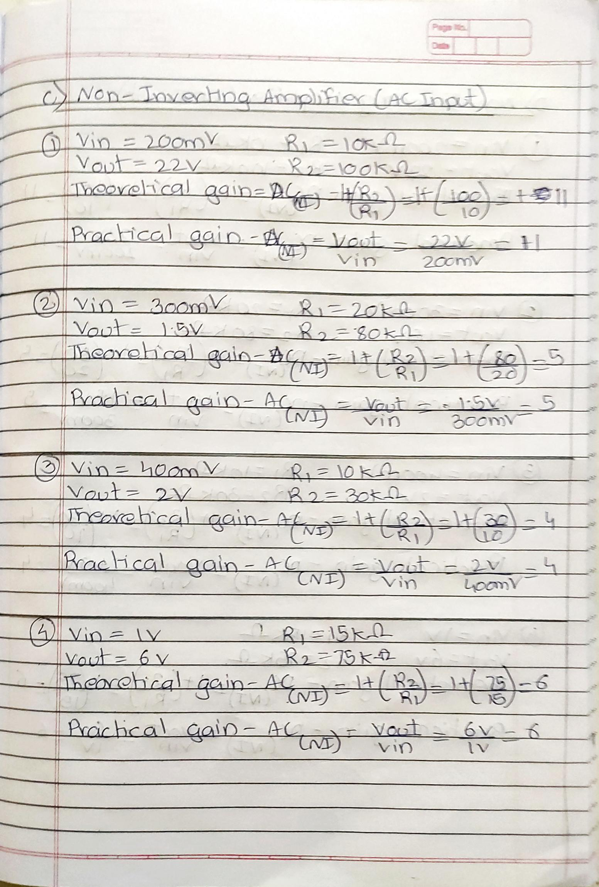

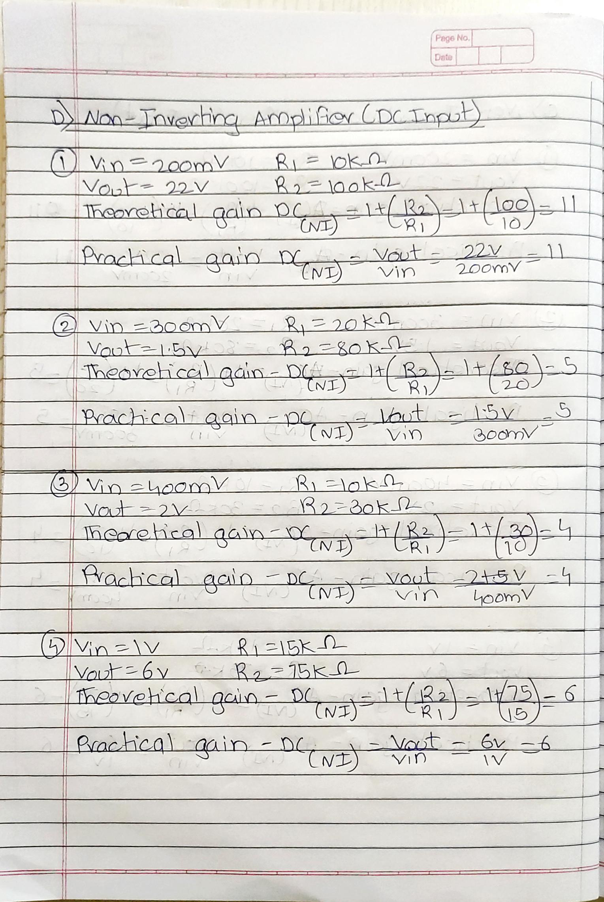

**Inverting Amplifier ( AC input)**

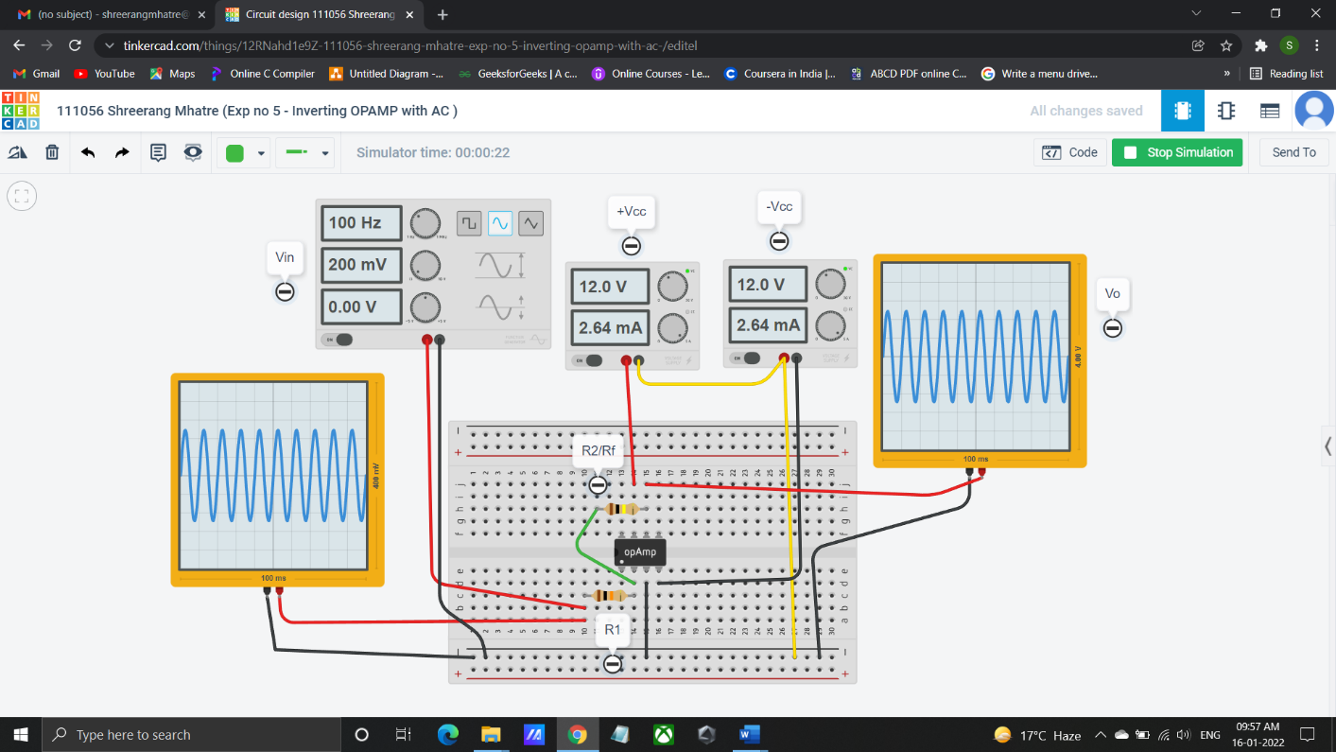

**Inverting Amplifier (DC input)**

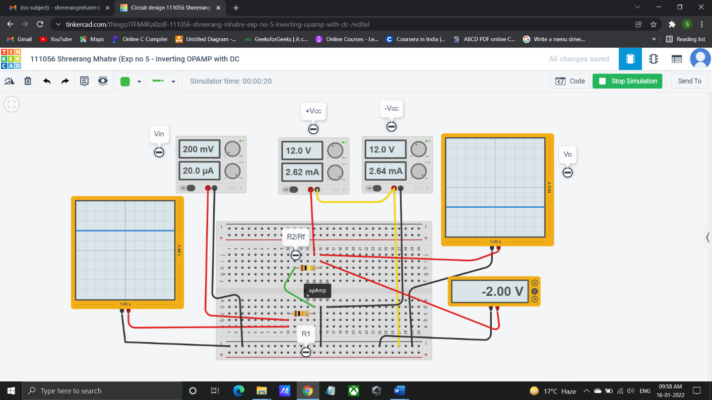

**Non-Inverting Amplifier (AC Input)**

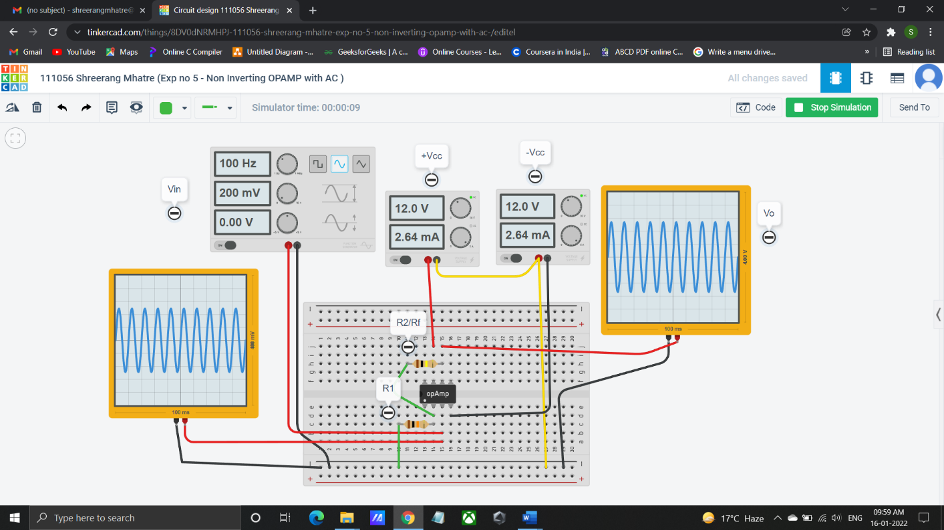

**Non-Inverting Amplifier (DC Input)**

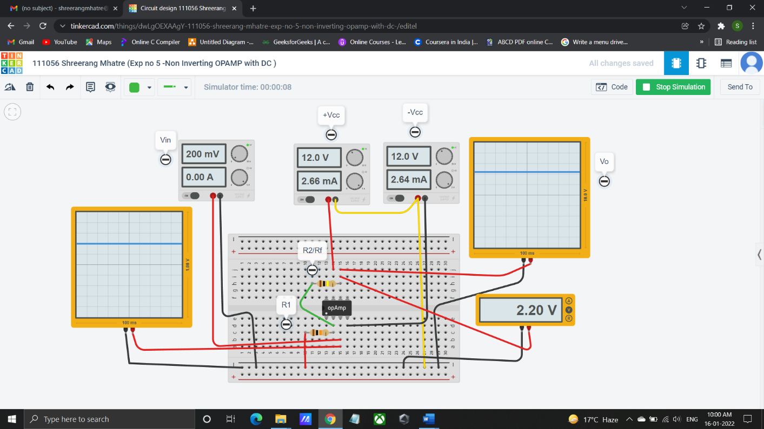

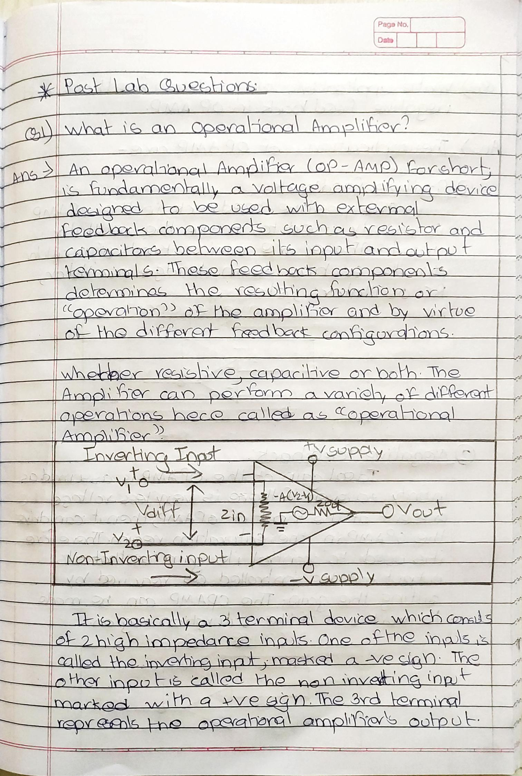

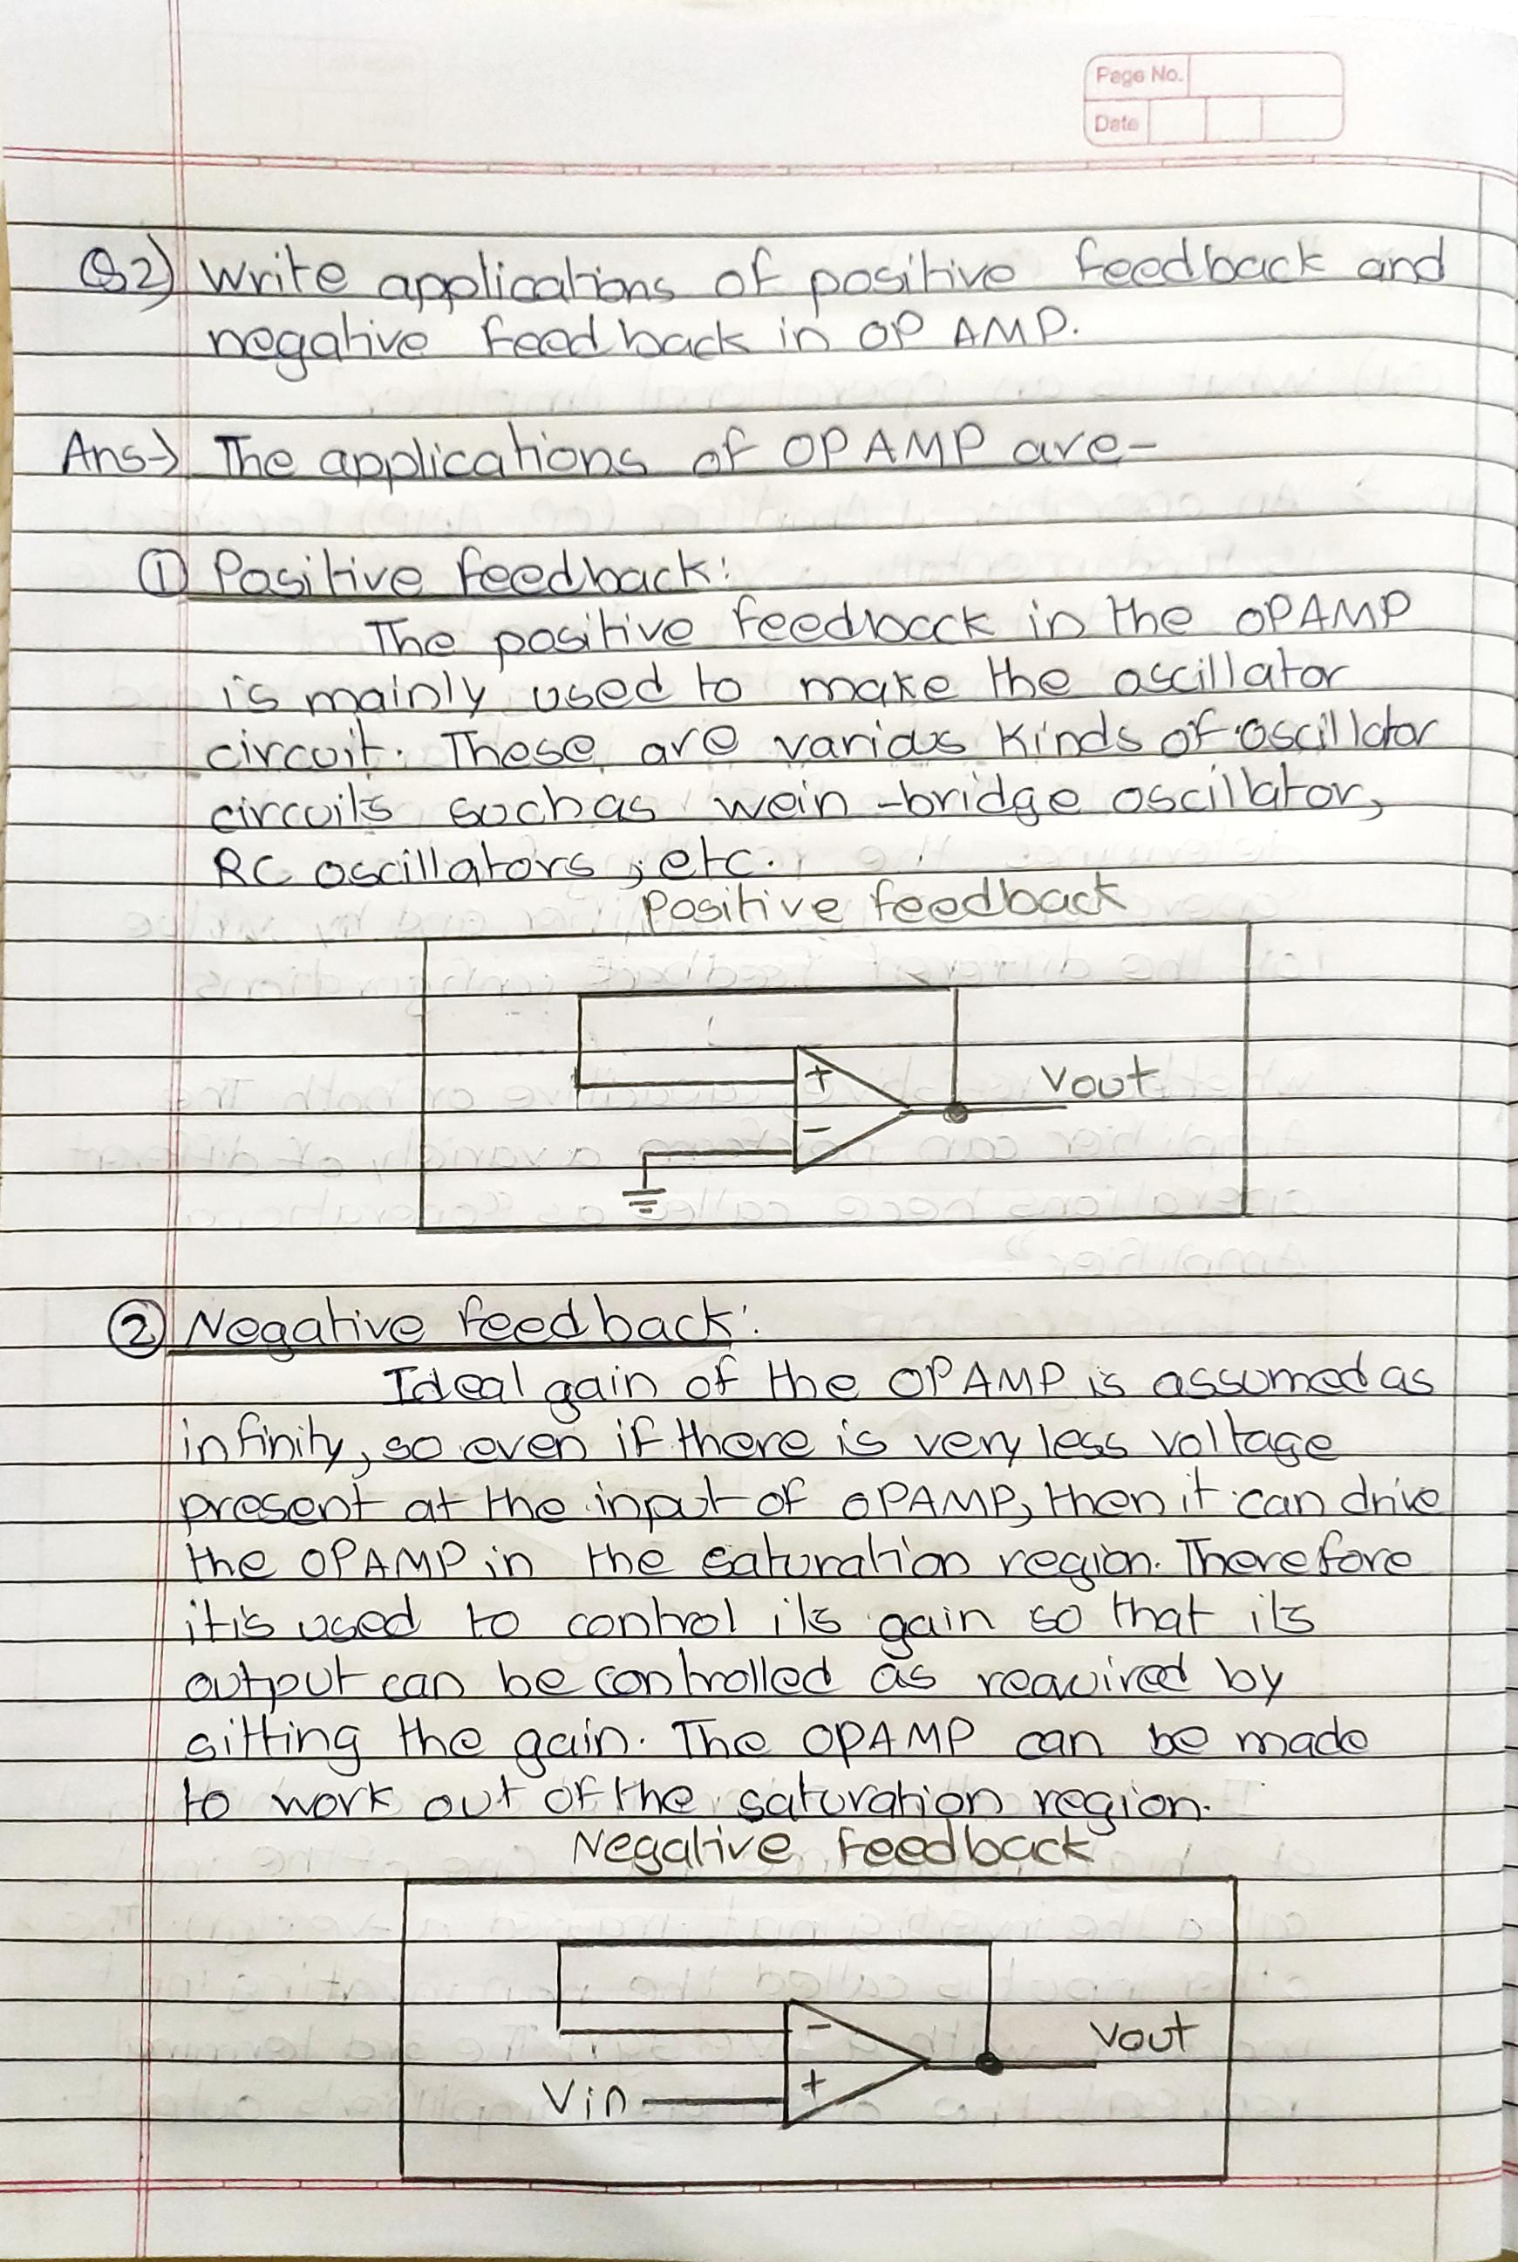

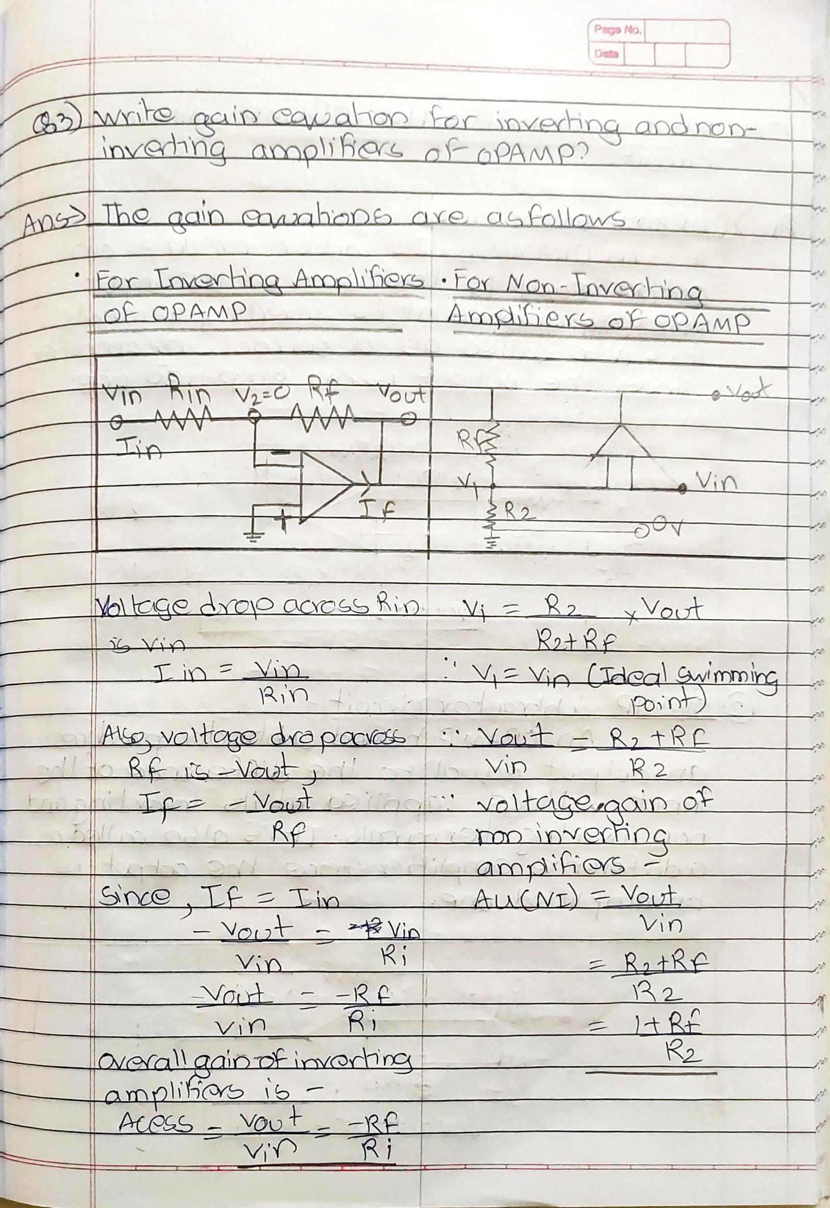

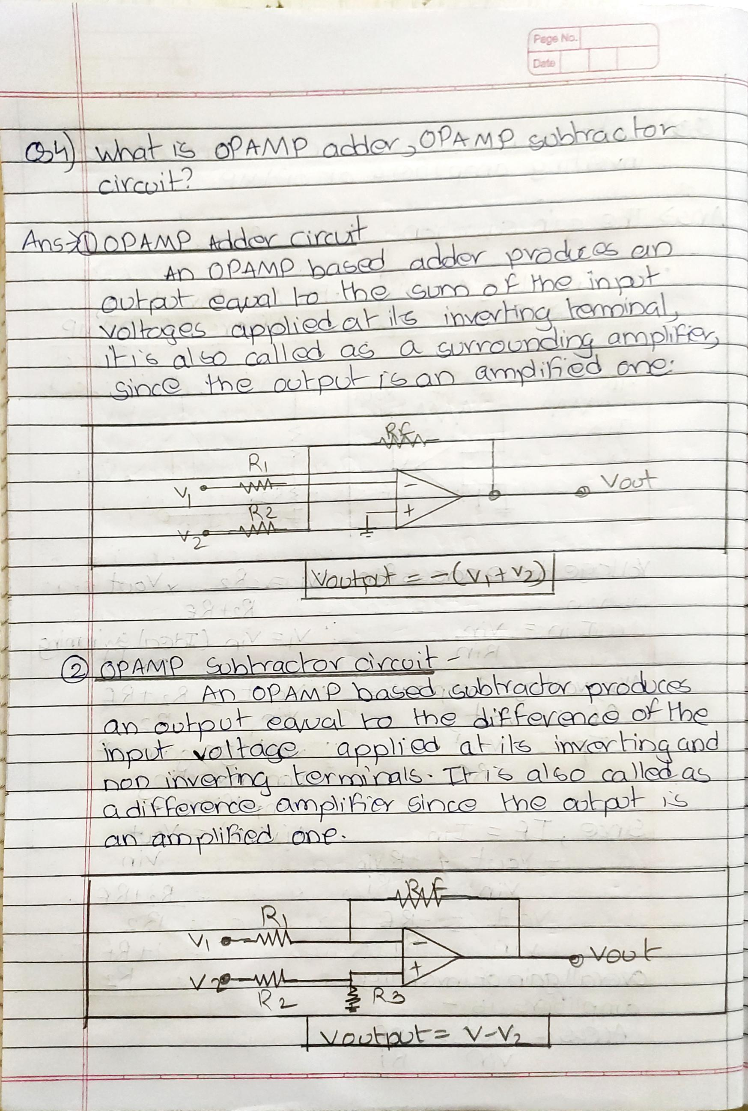

**Post Lab Questions:**

* + What is an operational amplifier?
  + Write applications of positive feedback and negative feedback in OP AMP.
  + Write gain equation for inverting and non-inverting amplifiers of OPAMP?
  + What is OPAMP adder, OPAMP subtractor circuit?

**Additional links for more information:**

* <http://dei.vlab.co.in/?sub=22&brch=60&sim=1119&cnt=2>
* <http://www.ti.com/lit/ds/symlink/lm741.pdf>